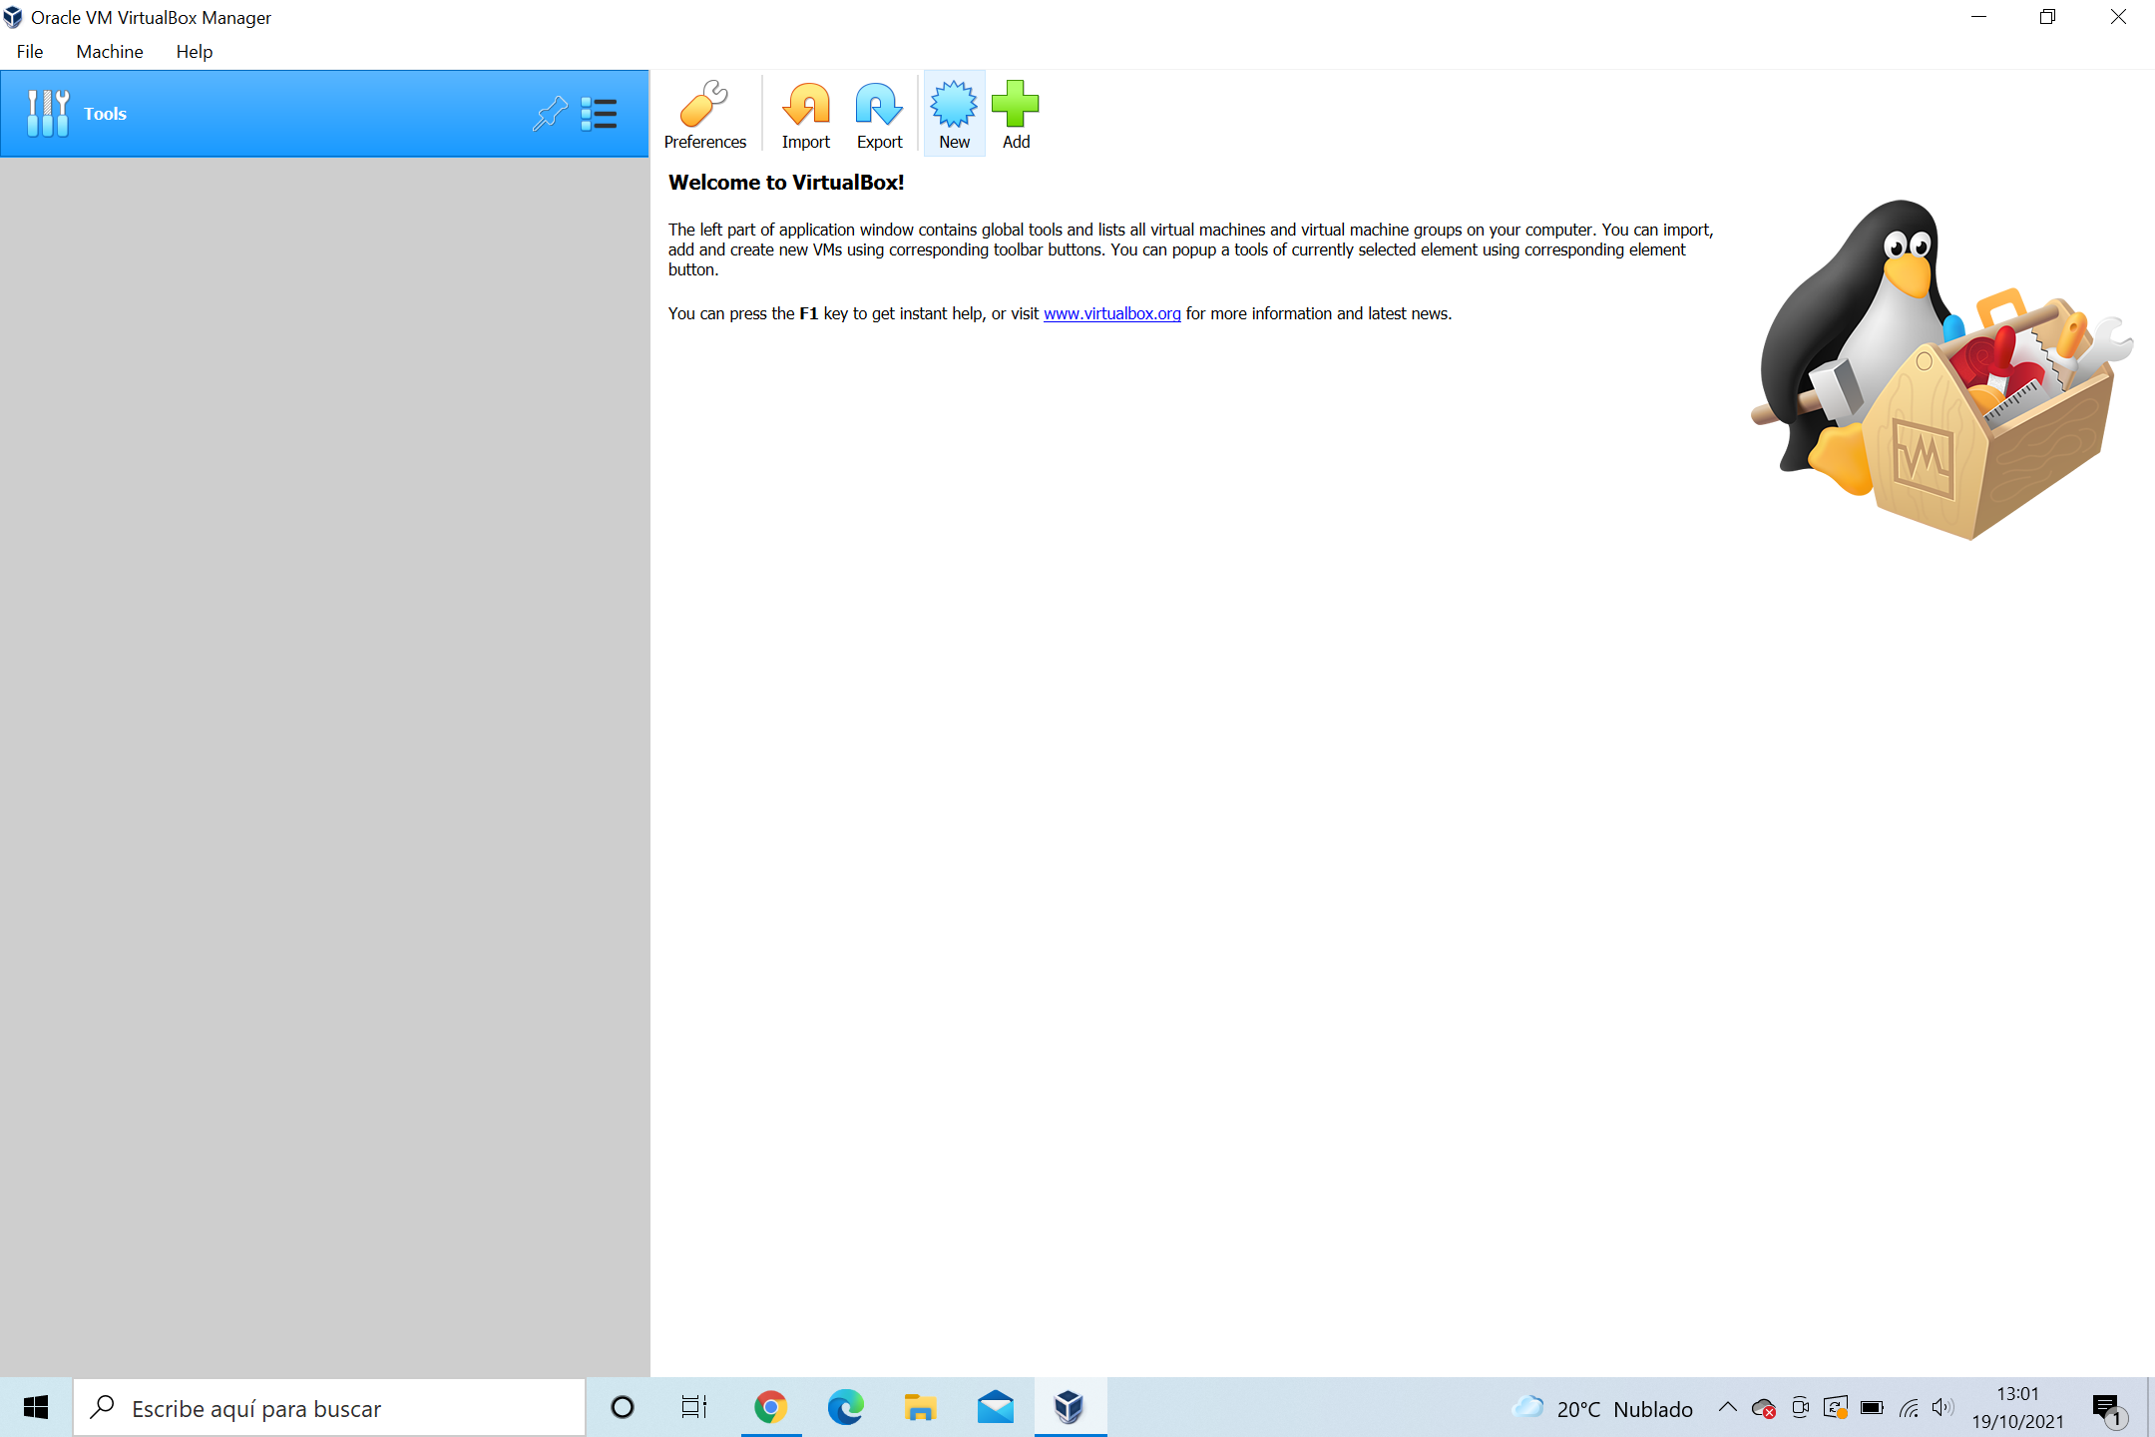

Do click in **New** to get started.

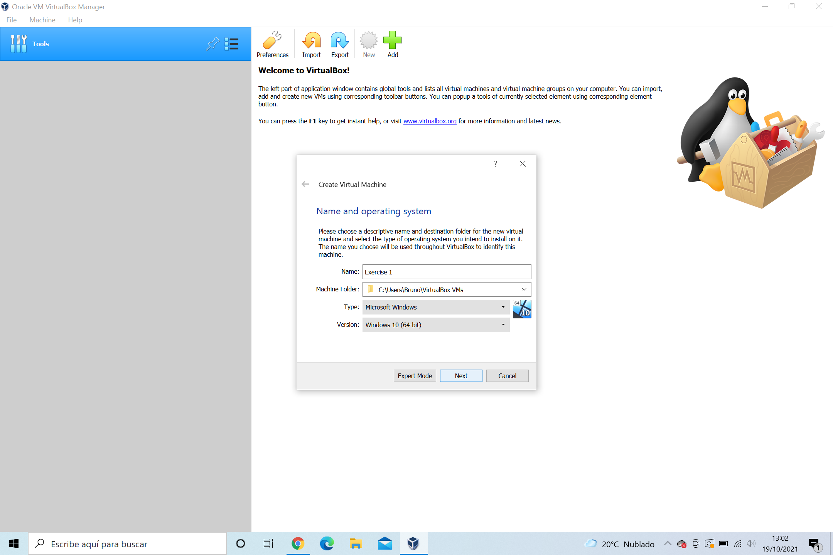

Put a name, in this case I have **Exercise 1, and choose the type Microsoft Windows, and the version Windows 10 as requested the exercise.**

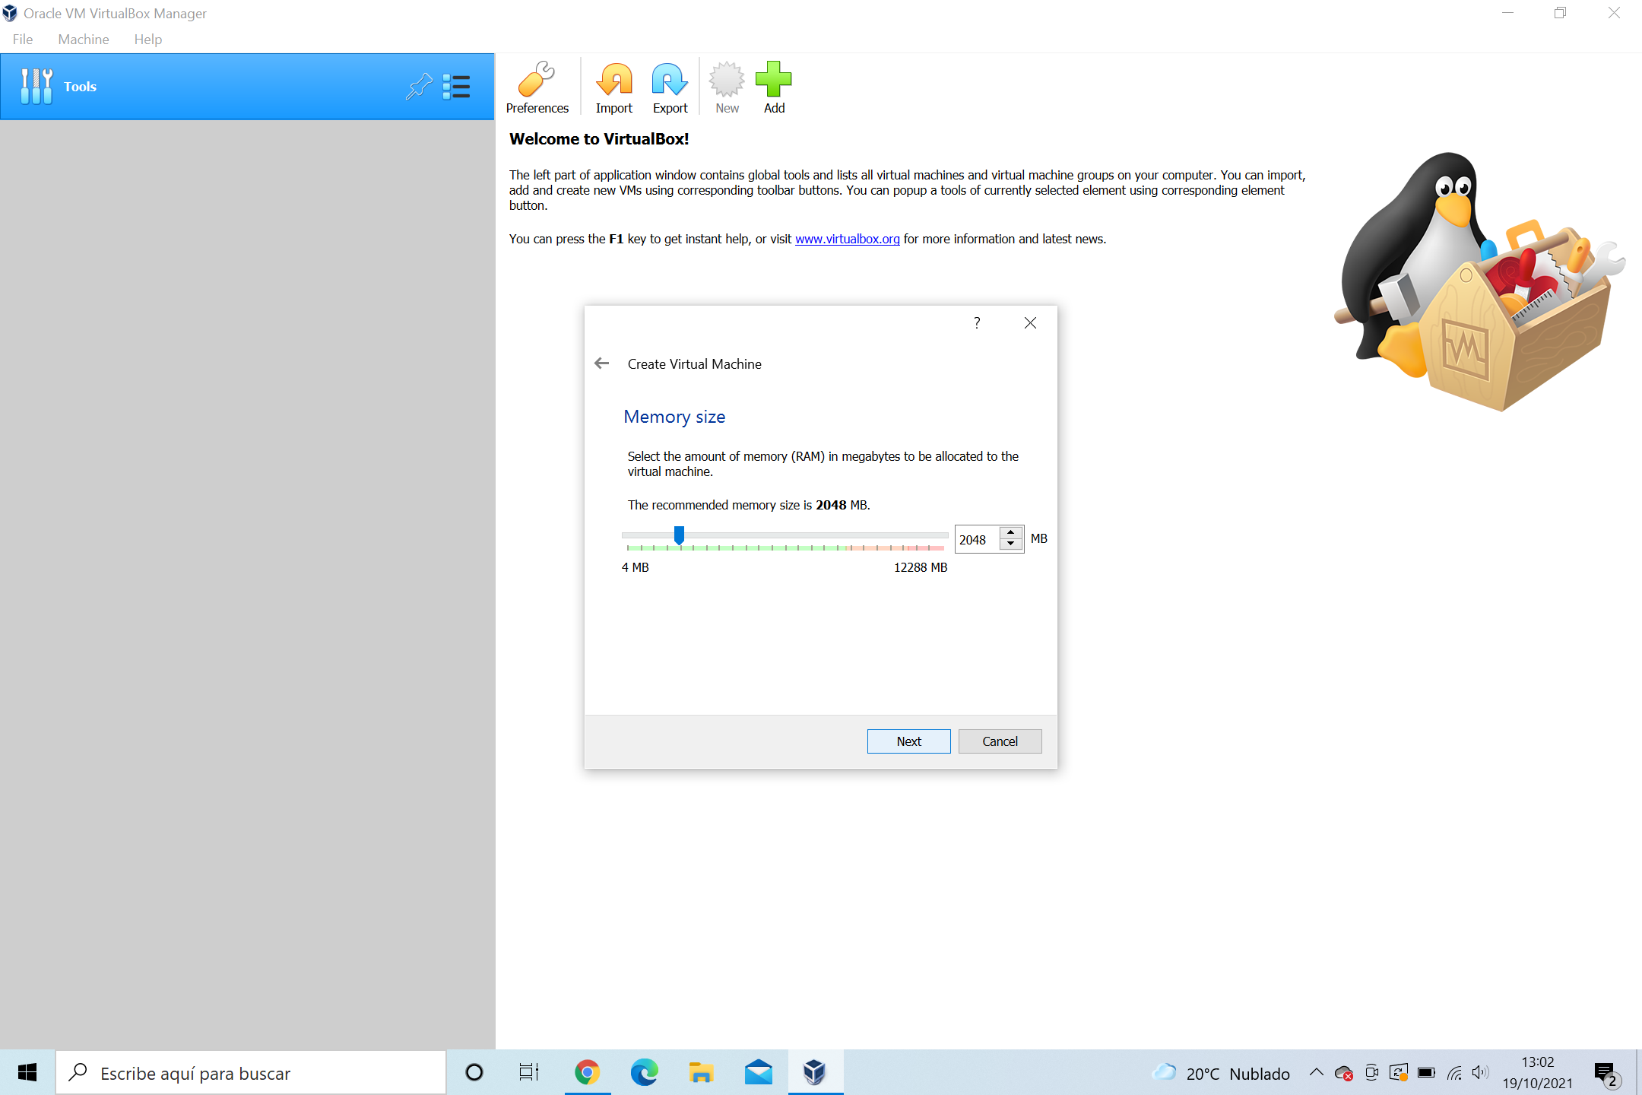

**The RAM have 2048 MB that is to say 2 GB this is the memory what is used to the operative system.**

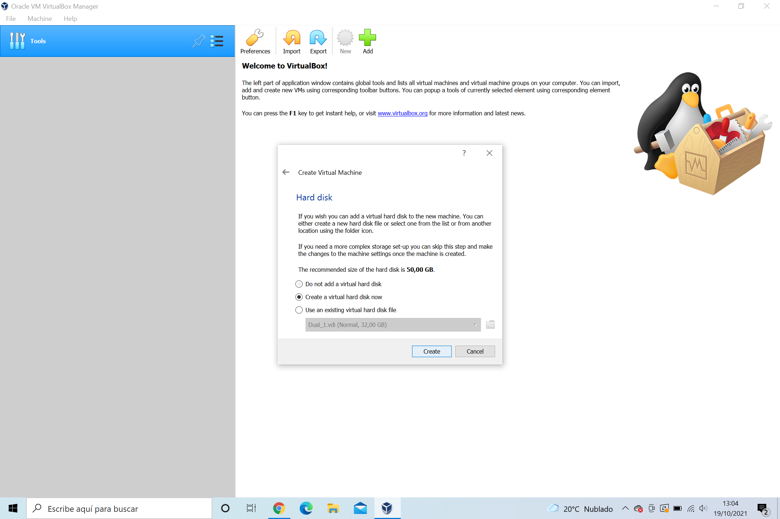

**Created the virtual hard disk with 50GB to have space in the VirtualBox, the type is VDI, and dynamically allocated, this use the hard disk files in the physical hard disk.**

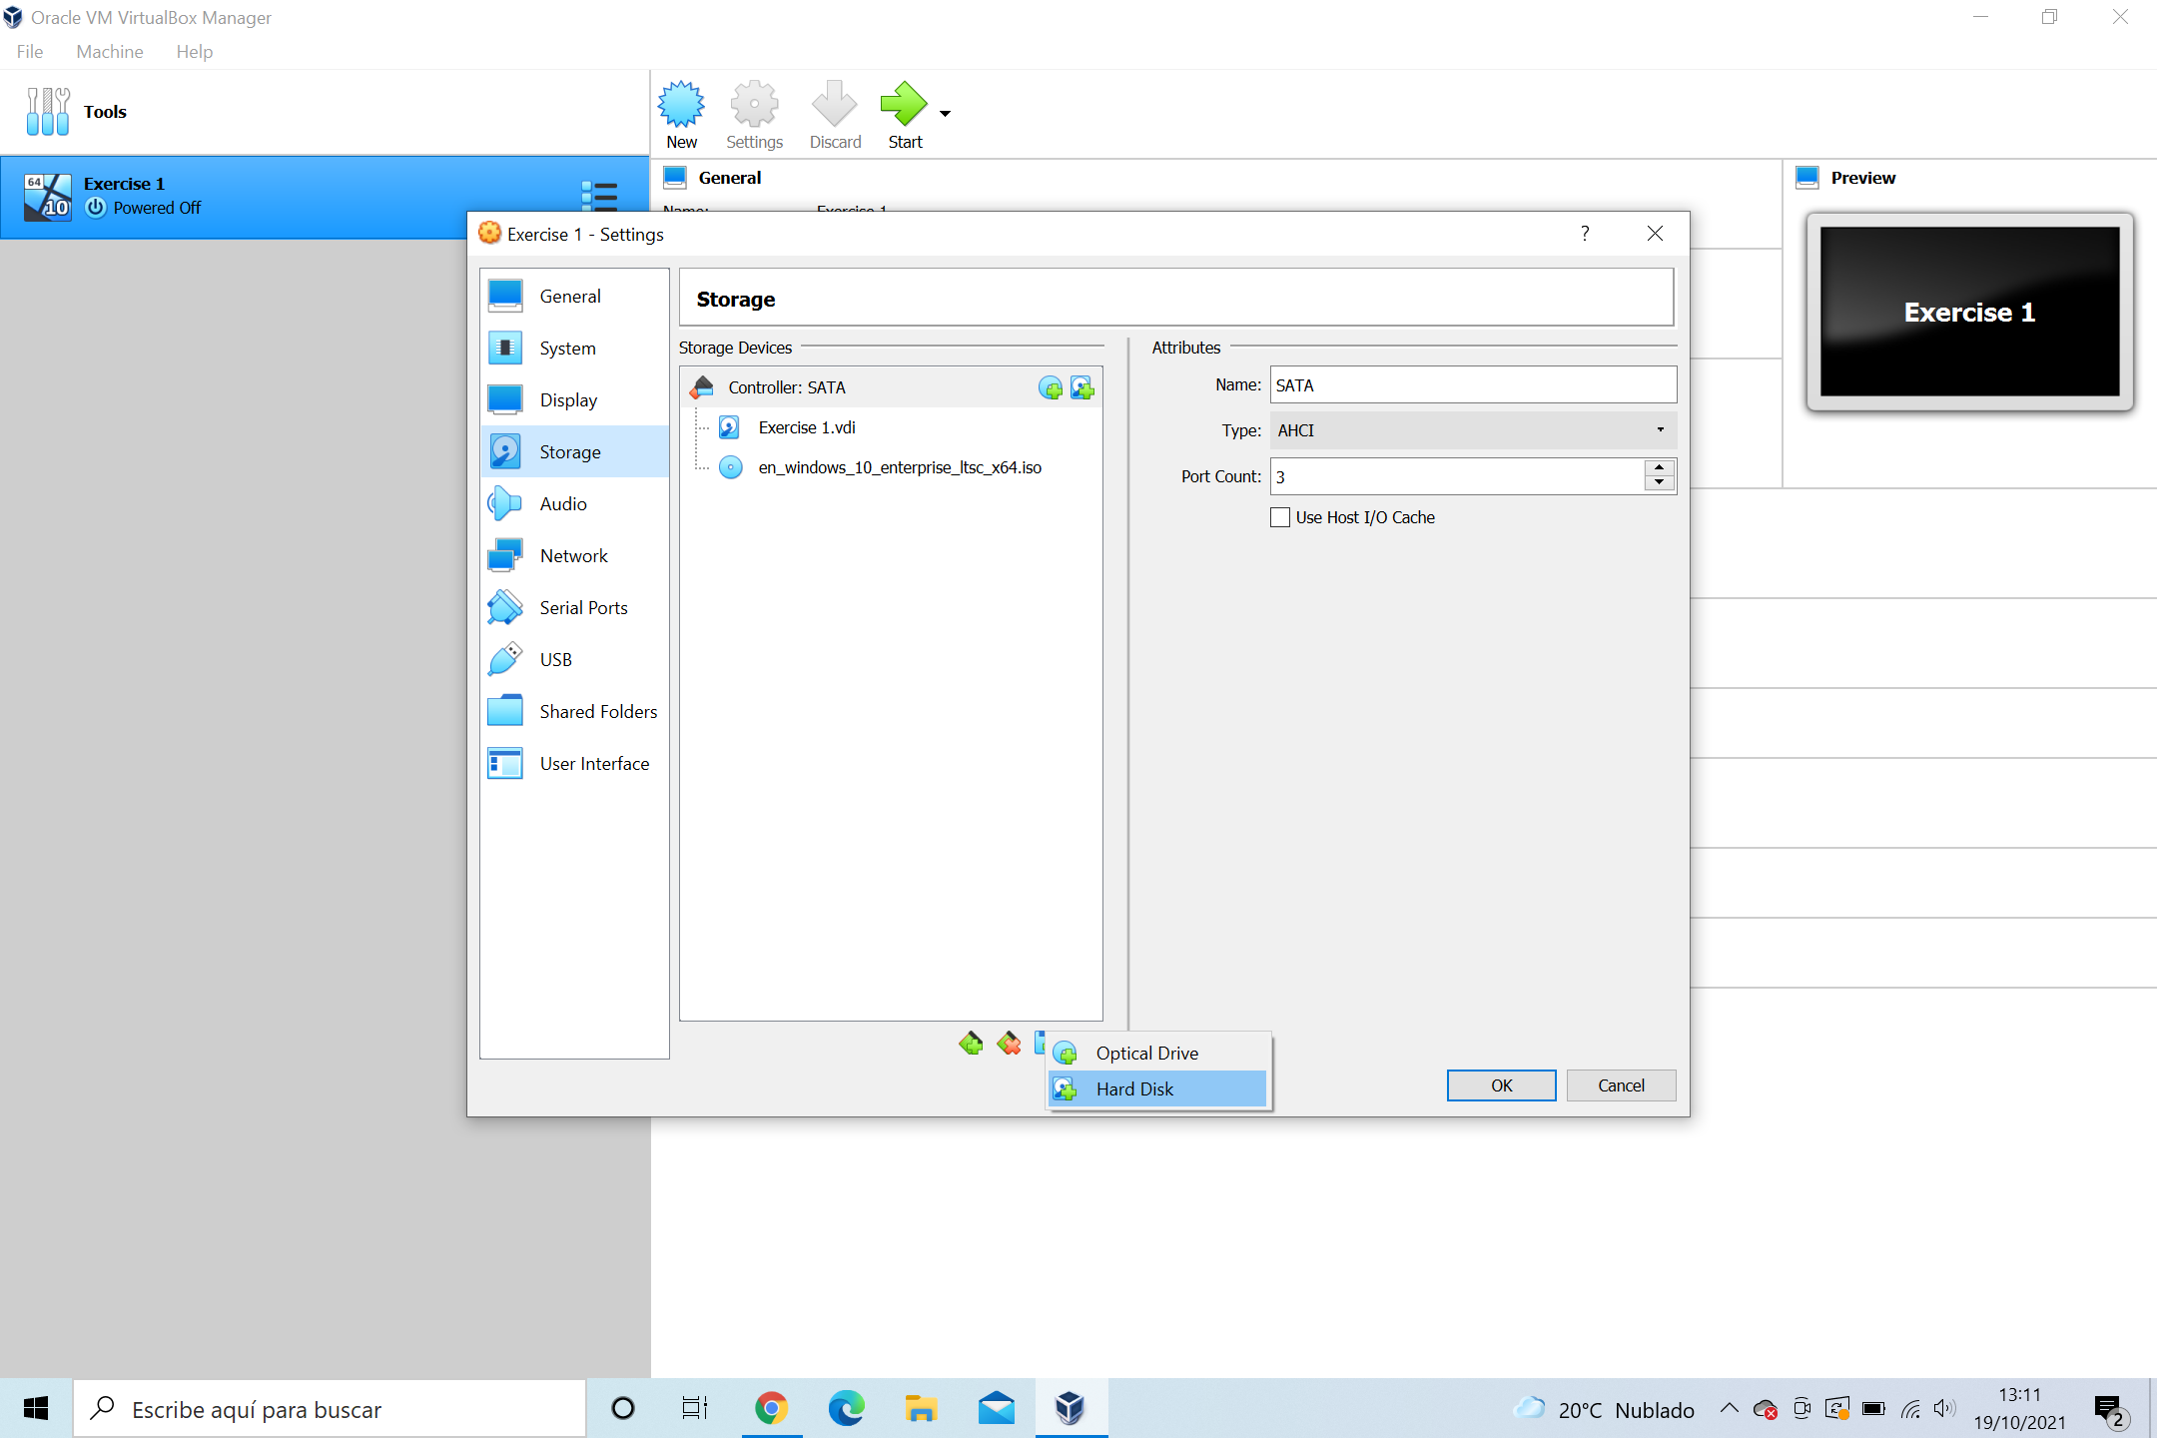

**In settings have a menu with the options, and specifically the option Storage, we do select add a new hard disk in this option to distribute the space.**

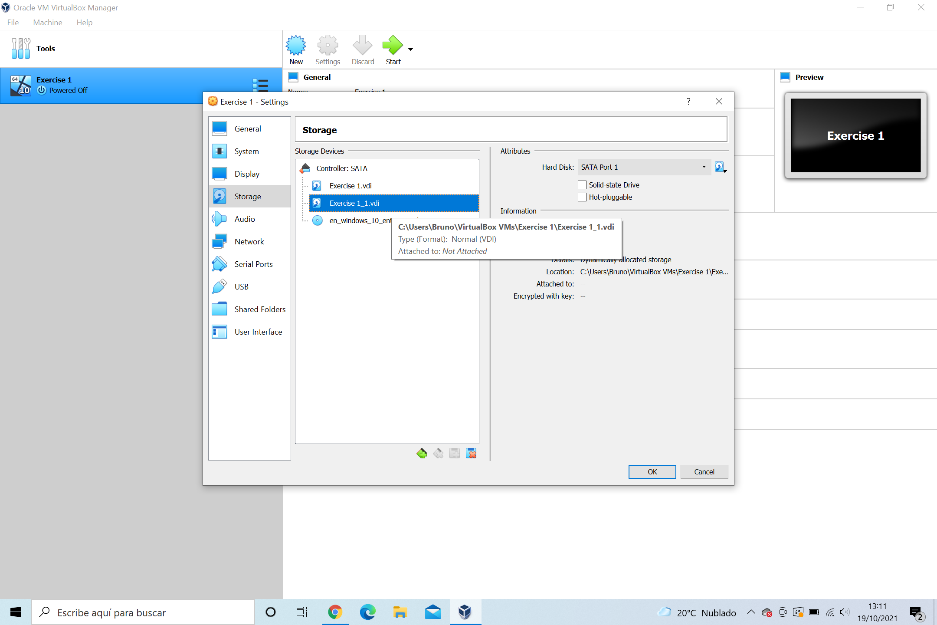

**Create other hard disk with 30GB with the previous options to the other hard disk.**

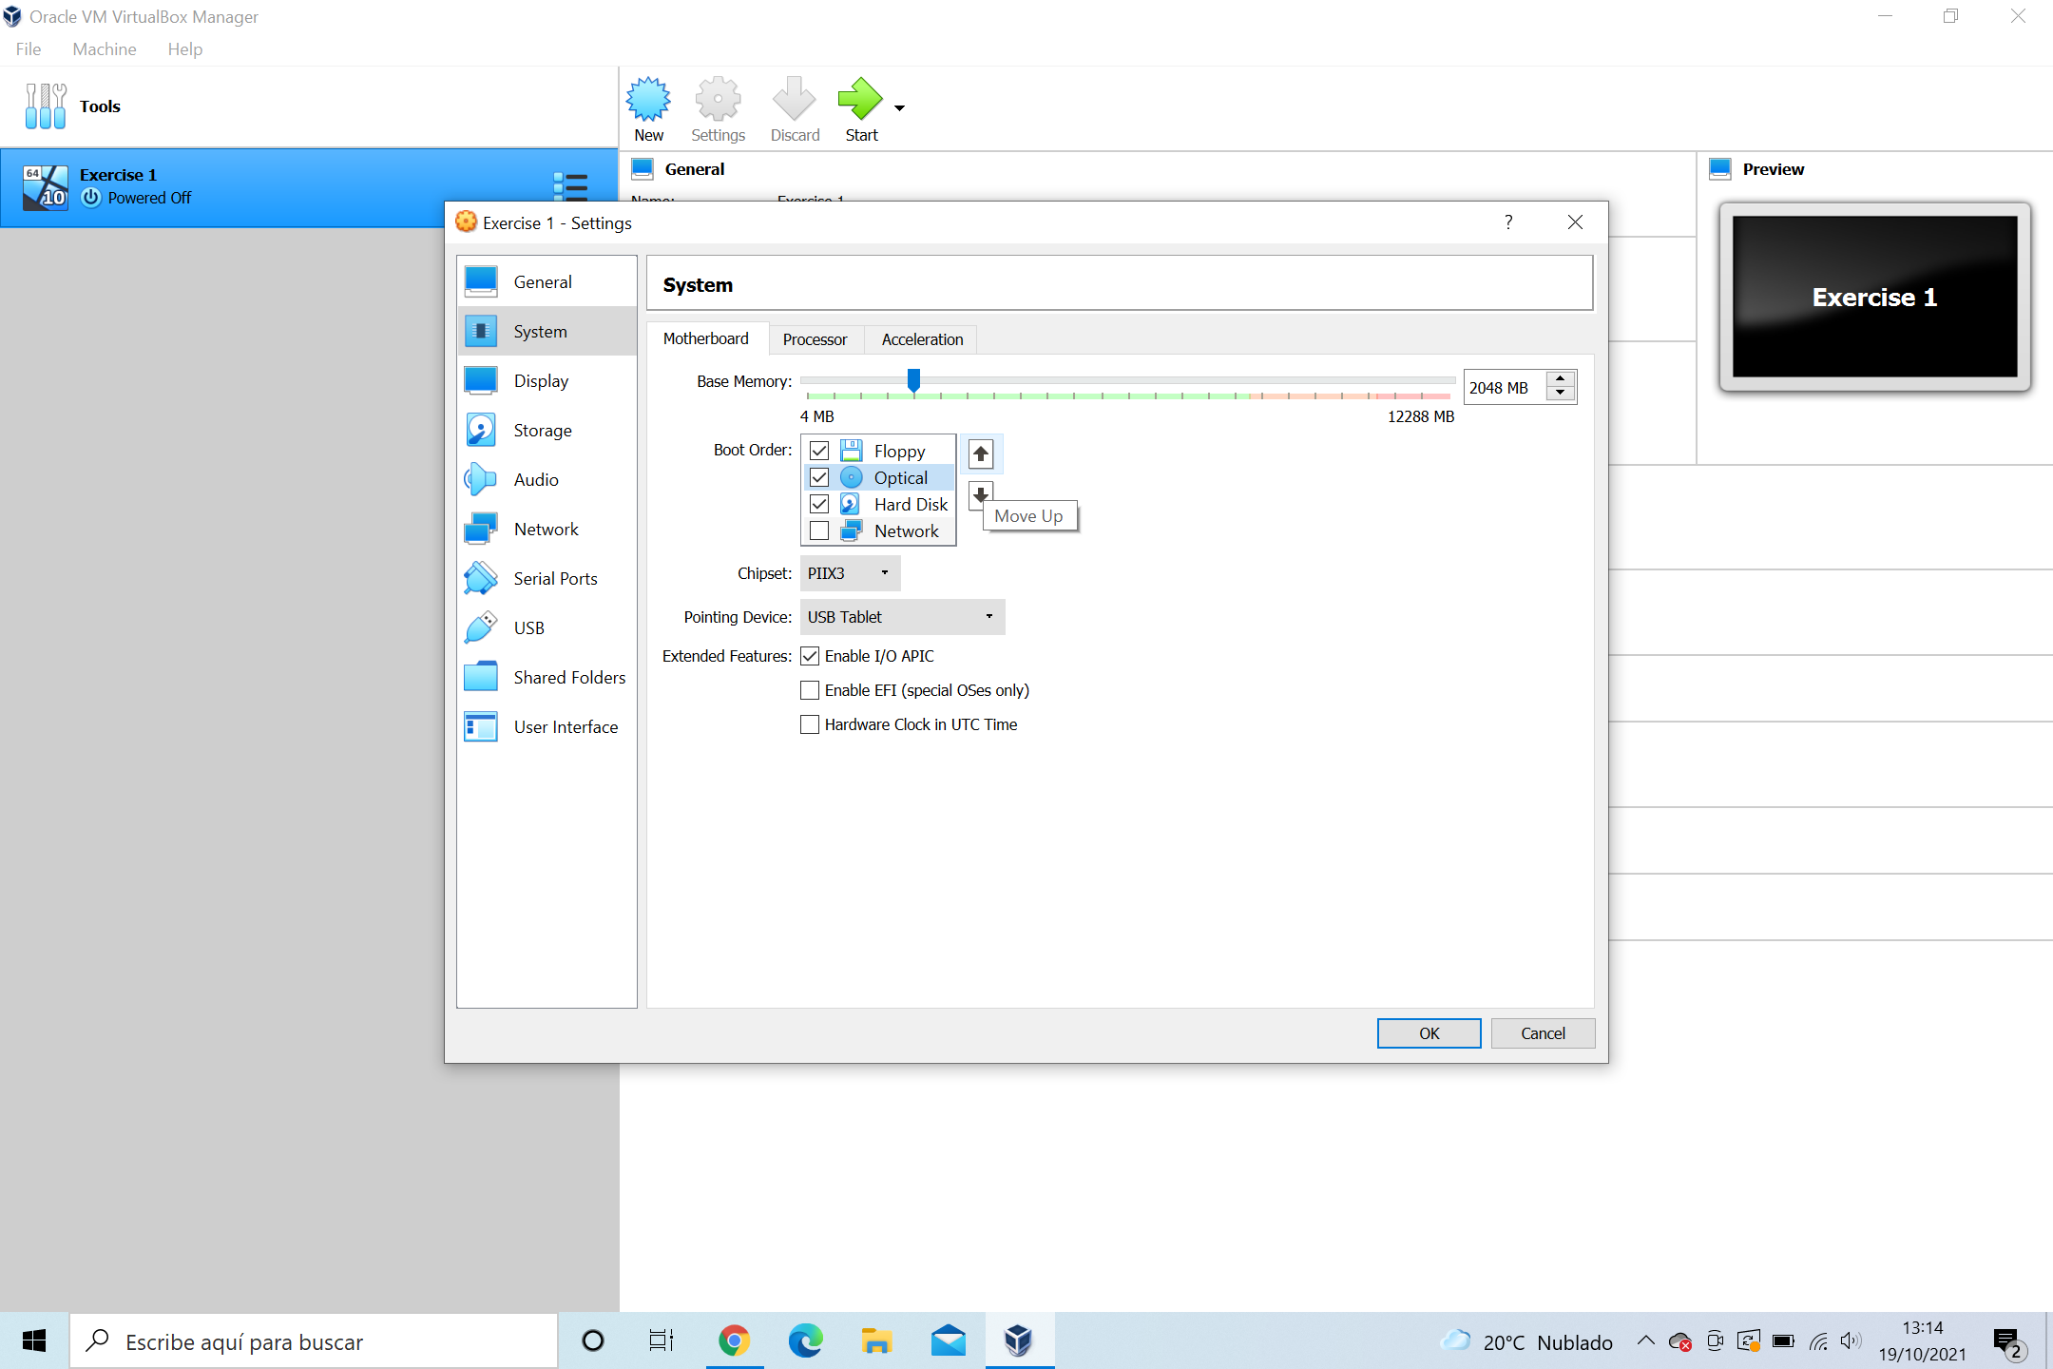

**In the System, have boot order so that everything works properly.**

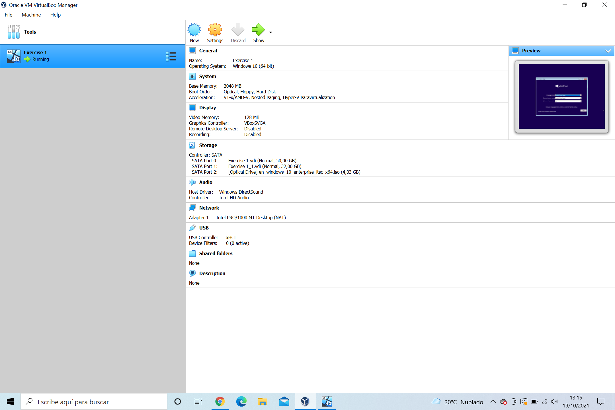

**And the final result is the outburst in the virtual machine.**